Chapter 12, Solution 35.

- This is a balanced three-phase system and we can use per phase equivalent circuit. The delta-connected load is converted to its wye-connected equivalent

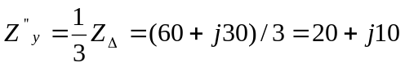

I_{L}

+

230 V Z’y Z’’y
-

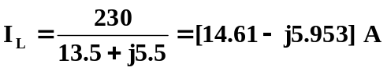

(b) 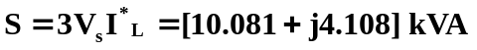

(c ) pf = P/S = 0.9261

